Battery-run vehicles add to Khulna’s power woes
30 Sept 2022 .
Src : https://www.thedailystar.net/news/bangladesh/news/battery-run-vehicles-add-khulnas-power-woes-3132111#:~:text=Mohammad%20Rafiqul%20Islam%2C%20professor%20of,the%20power%20shortage%20will%20reduce.%22

# According to Khulna's traffic department, there are over 30,000 battery driven easy bikes in the city. There are no statistics on the actual figures of electricity-powered vehicles, as they are mostly unregistered.

# According to experts and easy bike drivers, five batteries are used to operate an easy bike, with a 200 amperes capacity each. Rickshaws and vans use 4 batteries, which are 120 amperes each.
# 1 kilowatt of electricity is required to charge a 1,000 ampere battery for one hour.
# So, 10 kilowatts of electricity is needed to charge an easy bike for 10 hours .

# Rabiul Alam, license officer of Khulna City Corporation (KCC), said KCC issued license for 8,000 battery-run easy-bikes in the city and is in process of approving another 2,000.
# Azharul Islam, managing director of WZPDC, said they conduct drives against those who are doing commercial business with the permission of residential connection to charge battery-run vehicles.
He claimed that due to the illegal charging, WZPDC couldn't prepare the total electricity demand data accurately many times.

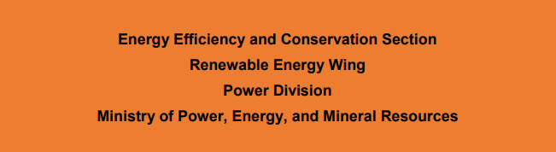

Src:https://file-khulna.portal.gov.bd/uploads/d07c3114-12a6-4ebe-8fa0-460e27018e82//671/5a0/75b/6715a075bfbf0518800500.pdf

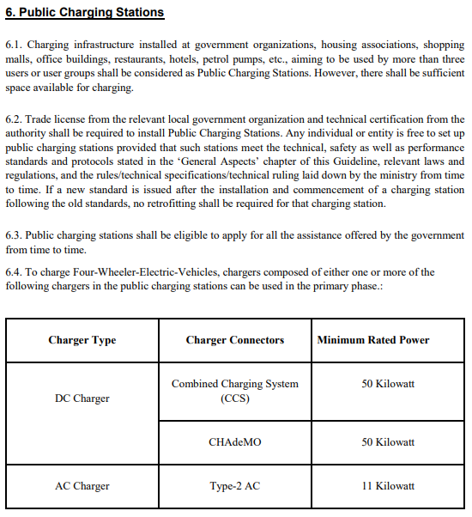

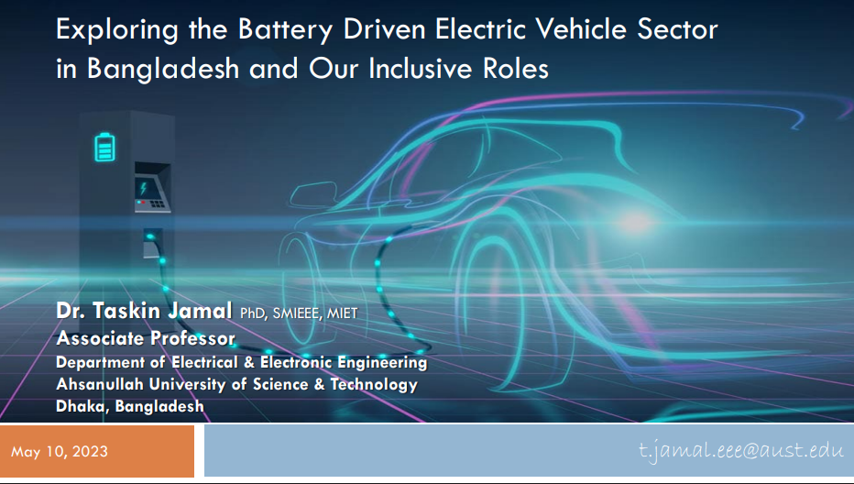
Src:
https://www.unescap.org/sites/default/d8files/event-documents/Day1-8Ahsanullah%20University%20of%20Science_Technology.pdf
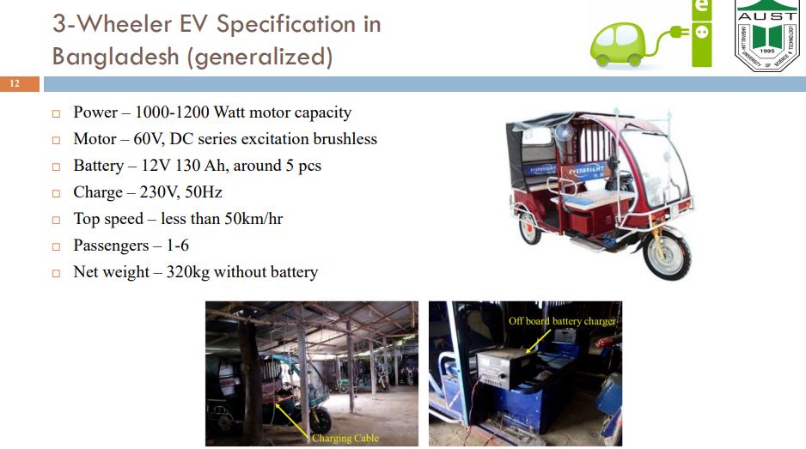

Elsevier :
High penetration of electric autorickshaw on national power system and barriers against the adoption of solar energy: A case study in Bangladesh
Src : https://www.sciencedirect.com/science/article/pii/S2666790823000423

# approximately 4660 MWh of electricity is consumed by autorickshaws in Bangladesh per day

Src : https://www.tbsnews.net/bangladesh/energy/relentless-load-shedding-plagues-khulna-barishal-residents-981976
As of Thursday at 1pm, demand across WZPDCL's 21-district service area reached 659 megawatts, but supply fell short at 560 megawatts, resulting in a 99-megawatt deficit. Khulna alone faced a load shedding of 45 megawatts, with other affected districts including Barishal (11 MW), Gopalganj (5 MW), Narail (2 MW), Magura (3 MW), Satkhira (2 MW), Kushtia (6 MW), Chuadanga (5 MW), Faridpur (6 MW), Rajbari (4 MW), Madaripur (4 MW), Shariatpur (2 MW), and Jhalokathi (4 MW). By nightfall, demand rose to approximately 700 megawatts across the 21 districts, with load shedding surpassing 100 megawatts.

Carrying full passengers in Easy Bikes can ease traffic, save power: Research

14 Sep 2025, 20:12
Update : 14 Sep 2025, 21:28

Src :https://www.bssnews.net/others/311737

Khulna City Corporation sources said 10,000 Easy Bikes are licensed to operate in the city. However, over 45,000 unauthorized Easy Bikes are also plying, creating immense congestion and hampering the daily movement of around 3 lakh commuters. These electric vehicles consume 450 megawatts of electricity daily, exerting tremendous pressure on the local power grid.

EVALUATING THE SOCIO-ECONOMIC AND ENVIRONMENTAL IMPACT OF BATTERY OPERATED AUTO RICKSHAW IN KHULNA CITY
Src :https://iccesd.kuet.ac.bd/2018/Papers/r_p4650.pdf

Multi-objective Optimization Strategy for Intelligent Charging and Discharging Station of Electric Vehicles in the Distribution Network
Src : https://ieeexplore.ieee.org/document/9511077

Global EV Outlook 2025
Src: https://www.iea.org/reports/global-ev-outlook-2025

Adaptive Traffic Signaling Control Using SUMO Simulator
Src: https://www.ijisrt.com/assets/upload/files/IJISRT25JAN158.pdf

Dynamic Load Balancing for EV Charging Stations Using Reinforcement Learning and Demand Prediction
Src: https://www.researchgate.net/publication/389714334_Dynamic_Load_Balancing_for_EV_Charging_Stations_Using_Reinforcement_Learning_and_Demand_Prediction

A Multicriteria GIS-Based Decision-Making Approach for Locating Electric Vehicle Charging Stations
Src: https://www.researchgate.net/publication/362470657_A_Multicriteria_GIS-Based_Decision-Making_Approach_for_Locating_Electric_Vehicle_Charging_Stations

ISSN Information:
DOI: 10.1109/NOMS59830.2024.10574932
Publisher: IEEE
Conference Location: Seoul, Korea, Republic of

Electric Vehicle charging station load forecasting with an integrated DeepBoost approach
Src: https://www.sciencedirect.com/science/article/pii/S1110016824016673
https://doi.org/10.1016/j.aej.2024.12.069Get rights and content
Under a Creative Commons license
Open access

A review on energy management systems in battery electric vehicles
Src:
https://www.researchgate.net/publication/400355371_A_review_on_energy_management_systems_in_battery_electric_vehicles

Microscopic Traffic Simulation using SUMO
Src: https://elib.dlr.de/127994/1/08569938.pdf
Or, https://www.researchgate.net/publication/329587763_Microscopic_Traffic_Simulation_using_SUMO
November 2018
DOI: 10.1109/ITSC.2018.8569938

